**Using Native Dynamic SQL to Recompile PL/SQL Code**

ALTER PROCEDURE d_a_table COMPILE;

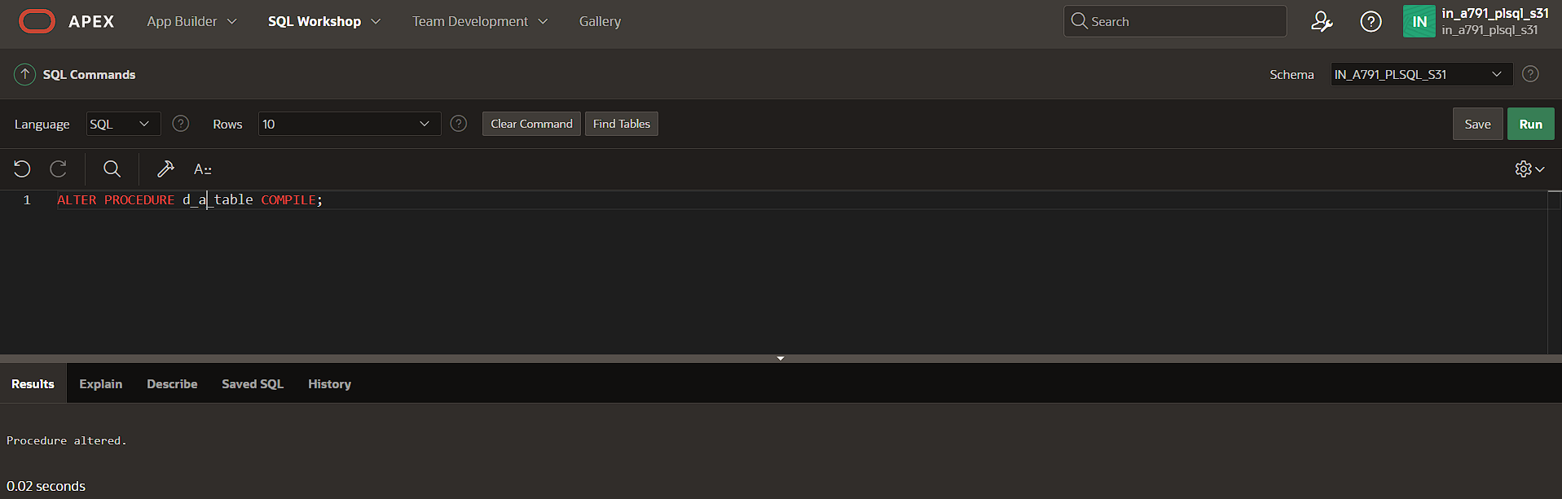

ALTER FUNCTION d_rows COMPILE;

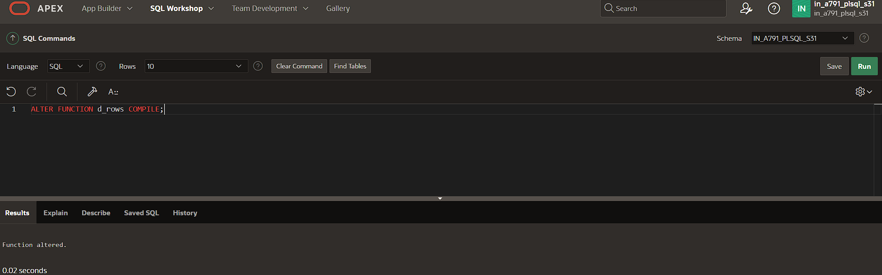

ALTER PACKAGE dept_pkg COMPILE;

